CENWP-OD 10 September 2009

MEMORANDUM FOR THE RECORD

Subject: FINAL minutes for the 10 September 2009 FPOM meeting.

The meeting was held in the St. Helens Room at NOAA’s Portland Office. In attendance:
Last | First | Agency | Office/Mobile | Email
Baus | Doug | USACE RCC | 503-808-3995 | Douglas.M.Baus@usace.army.mil
Benner | David | FPC | 503-230-7564 | dbenner@fpc.org
Bettin | Scott | BPA | 503-230-4573 | swbettin@bpa.gov
Cordie | Bob | USACE TDA | 541-506-7800 | Robert.p.cordie@usace.army.mil
Dykstra | Tim | USACE NWW | 509-527-7125 | Timothy.A.Dykstra@usace.army.mil
Erickson | Don | USACE NWP | 503-808-4713 | Donald.L.Erickson@usace.army.mil
Fredricks | Gary | NOAA | 503-231-6855 | Gary.fredricks@noaa.gov
Hevlin | Bill | NOAA | 503-230-5415 | Bill.hevlin@noaa.gov
Klatte | Bern | USACE NWP | 503-808-4318 | Bernard.a.klatte@usace.army.mil
Lorz | Tom | CRITFC | 503-238-3574 | lort@critfc.org
Mackey | Tammy | USACE | 541-374-4552 | Tammy.m.mackey@usace.army.mil
Martinson | Rick | PSMFC | 541-296-8989 | rickdm@gorge.net
Meyer | Ed | NOAA | 503-230-5411 | Ed.meyer@noaa.gov
Rerecich | Jon | USACE BON | 541-374-7984 | Jonathan.g.rerecich@usace.army.mil
Sawka | Mark | USACE NWP | 503-808-4951 | Mark.J.Sawka@usace.army.mil
Stansell | Robert | USACE FFU | 541-374-8801 | Robert.j.stansell@usace.army.mil
Swanson | Larry | NOAA | 503-230-5448 | Larry.swenson@noaa.gov
Sweet | Jason | BPA | 503-230-3349 | jcsweet@bpa.gov
Wills | David | USFWS | 360-604-2500 | David_wills@fws.gov
Benner, Cordie, Erickson and Hevlin called in.

- Finalized results from this meeting.
  - August FPOM minutes approved.
  - FPOM says the analysis needs to be done regarding the benefits of the LGS spillbay weir. If the data shows a benefit for sub-yearlings, keep the RSWs open until the end of spill. If no benefit is seen, the argument could be made to close them early.
  - FPOM approves the late October outage for the BON spillway survey.
  - FPOM approves removal of the PH1 fish screens and DSM1 dewatering on 19 October. BON will operate the unit under the chaingate with the largest opening.
  - LMN fish mortality. FPOM decided to leave the process as it is. Dykstra will provide updates at the next FPOM and Bailey can include the information in the weekly report. No need for anymore special announcements.
  - FPOM says ok for the CI velocity measurements to occur during the same day as the BON spill survey. More details will be provided at the October FPOM.
  - BON gantry 3 crane rail. FPOM approves the work on 15 September and the work in late October, but they would like to know why ground penetrating radar can’t be used.
  - FPOM requested the MCN traveling screens be discussed at the October FFDRWG, with drawings and screen details.
  - FPOM decided the NWW updates, normally provided by Bailey, is no longer needed.

- The following documents were provided or discussed.
  - Agenda, Fish Passage O&M Coordination Team.
  - Washington Shore FVB roof replacement. Pages 8-12
  - LWG inspection of adult fish trap and water supply pipe. Page 13
  - MCN entrance velocity test results. Pages 14-18
  - NOAA memo regarding TDA ITS operation. Pages 19-21
  - NWP winter maintenance schedules. Pages 22-26
  - FFU JDA-N study. Page 27
  - Fisheries calendar. Pages 28-30
  - 17 August 2009 BON AFF meeting notes. Pages 31-32
  - NWW updates. Pages 33-34

- Action Items
  - [Jun 09] BON spillway repairs. ACTION: Lee will provide updates to FPOM. STATUS: Plans and specs complete but postponed due to funding. Lee’s drafting a memo to explain the urgency and elevate the issue. This will remain on the agenda.
  - [Jun 09] JDA fish ladder outages. ACTION: Kruger will ask about ODFW concerns. STATUS: no updates. This will be removed.
  - [Aug 09] MCN crane. ACTION: Dykstra will provide an update when possible. STATUS: Crane 5 main hoist is tagged out and will remain so for several months. The delay is due to needing independent inspectors and getting it cleared for service. The hammerhead portion is still functional and is being used to clean VBSs. The back-up plan is to have a mobile crane, expected to arrive by 14 September, to lift headgates. The crane will remain on-site until Crane 5 is fully functional.
  - [Aug 09] LGS spillbay weir. ACTION: Dykstra will send the study to Kiefer. STATUS: Dykstra has not yet sent the study to Kiefer; in fact he can’t remember which study he was supposed to be sent. There isn’t any LGS study to send. Bettin asked about the operation since there wasn’t enough water to operate properly. Dykstra commented that the FPP had actions included. He wants to bring that information into the main body of the FPP rather than the footnotes. Fredricks commented that the key is the efficiency of downstream migration for juveniles. He recommends looking at the studies available; while most of them end in August, they still provide good information. He wants NWW to look at efficiencies by bay. Fredricks doesn’t believe there is much benefit for sub-yearlings. Hevlin interjected that he disagrees with several comments. He said that the RSW data has been surprising; sub-yearlings have used the RSWs in high numbers. He doesn’t see any reason to shutoff the RSWs until the end of spill. FPOM says the analysis needs to be done so everyone can see the data. If the data shows a benefit, keep the RSWs open, if not, then close them.
  - [Aug 09] LWG operation of fish trap. ACTION: Dykstra will provide an updated report to FPOM in September. STATUS: please see the attached document. The engineers thought the pipe was concrete but upon closer inspection, it may not be concrete, just very corroded. Sean Milligan has determined that the calculations are correct and there should be enough water, but there isn’t. LWG may get a new facility and that may solve this issue, but for now, there isn’t much that can be done.
  - [Aug 09] MCN lamprey entrance test. ACTION: D. Fryer to send data to FPOM. STATUS: please see the attached document. Dykstra commented that the main purpose of the test was to make sure there were no negative impacts to salmonid passage. The data show there do not appear to be any impacts to salmonid passage. Fredricks says he isn’t so concerned about the testing that was done but he is concerned about the future plans, such as cutting holes in the weirs. Meyer asked about a 4” x 12” hole in the weir improve lamprey passage. Dykstra will get more information. Fredricks would like to talk about this issue more at the October FFDRWG and FPOM.
  - [Aug 09] MCN temperatures. ACTION: Lorz to draft FPP change form. STATUS: listed in item #14.
  - [Aug 09] BON split flows. ACTION: NWP to draft FPP change form clarifying that split flows can only occur when flows exceed 100kcfs. STATUS: listed in item #14.
  - [Aug 09] BON ITS automated gates. ACTION: Rerecich to provide update in Sept. STATUS: completed.
  - [Aug 09] BON spillway survey. ACTION: Mackey to find out why survey can’t wait until October. STATUS: completed.
  - [Sep 09] BON FVB roof. ACTION: Sawka will get more construction details and bring it back to FPOM in October.
  - [Sep 09] BON FVB roof. ACTION: Sawka will send Mackey a PDF of his handout. STATUS: completed on 10 September. Included with the minutes.
  - [Sep 09] LGS spillbay weir. ACTION: Mackey will listen to the August meeting and determine which study Dykstra needed to send. STATUS: completed on 13 September.
  - [Sep 09] LGS spillbay weir. ACTION: Dykstra will task Planning with doing the analysis of the benefits of the RSWs to sub-yearlings, as requested by FPOM.
  - [Sep 09] TDA ITS operation. ACTION: Fredricks will send Mackey a copy of his handout regarding TDA ITS operation for inclusion in the minutes. STATUS: completed on 23 September.
  - [Sep 09] NWW winter maintenance schedules. ACTION: NWW will provide winter maintenance schedules for the October FPOM.
  - [Sep 09] ARRA funded projects. ACTION: NWW will update this list with their projects for the October FPOM.
  - [Sep 09] FPP change forms for Appendices J and K. ACTION: Martinson will send his proposed language to Rerecich.
  - [Sep 09] BON AFF minutes. ACTION: Klatte will set a meeting for early November.
  - [Sep 09] BON AFF minutes. ACTION: Mackey to define short-term issues for FPOM.

- Washington Shore FVB roof replacement. Mark Sawka handed out a document describing the background behind the existing roof and the plans for a new roof. Fredricks asked about any changes to the design. Sawka commented that he didn’t like the columns in front of the windows. He would like to see them sitting on the wall. There are some structural issues, but he is working on it. By moving the columns to the wall, the excavation on the north side may be eliminated. Fredricks asked if there was any rock on the north side. Sawka said it is only fill; there are no large rocks or bedrock.
  - The new schedule shows construction starting in May 2010. Due to that, FPOM needs to know exactly what activity will occur. FPOM had several questions. There was talk about wall failure before, so does the ladder need to be dewatered? Can it be dewatered? Can the work be done at night?
  - Fredricks and Lorz didn’t express too much concern about excavation on the north side since there shouldn’t be any large rock removal. They did stress that most of this work will probably need to occur during the winter work season, but they will try to work with Sawka on the schedule.
  - Baus mentioned the need for a containment plan to keep concrete and splatter out of the ladder. This is normally included in the contract.
  - Sawka will try to accelerate the schedule for the exaction and concrete. He said the roof construction will be done outside the winter maintenance period since the trusses have to be fabricated off-site.
  - Fredricks asked where the gutter was going to go. Sawka thinks the new gutters might tie into the existing gutters. It was suggested they be directed into rain barrels and used for irrigation.
  - ACTION: Sawka will get construction details and bring it to FPOM in October.

- BON PH1 DSM screen removal. NWP would like permission to remove fish screens and dewatering DSM1 starting mid-October so contractors can start removing orifice components from the DSM. While the dewatering of the ITS won’t start until 1 November, screen removal was not accounted for though. Would like to remove the screens on 19 October and move to the north end of the powerhouse so they are out of the way.
  - FPOM discussed the forecasted water flow and the need to operate a PH1 unit to maintain flow at the high head, which is a result of the TDA spillwall work. Fredricks asked about the chaingate settings at 1B. Rerecich reported that 1C was opened and 1B was closed.
  - FPOM approves the early removal of the fish screens. BON will operate the unit under the chaingates with the largest opening. DSM1 will be dewatered when the screens are pulled.

- BON stilling basin survey. NWP requests 1 hour closures for spill bays 1 and 18 on one day the week of 26 October. One bay will be closed at a time while the stilling basin and shoreline is surveyed. FPOM approves the late October outage.

- Updates.
  - BON Fish unit trash rake. Klatte reported the money will get to BON by 17 Sept. Once the Project has the money, they can fabricate the brackets and test it.
  - BON ITS automated gates. When the ITS is dewatered, the contractor can inspect gate 6 and the end gate. The automated gates now communicate with the Control Room, though they are still not automated yet. Bettin asked what the ITS is operated for. Fredricks and Lorz commented that the ITS is for adults, juveniles and lamprey, as well as whatever other fish wants to come through.
  - BON Bay 15 hoist. Rerecich reports the motor will be sent for repair in FY10 and should be installed and operable by the 2010 spill season. FPOM asked about the 32 week lead time and whether the 2010 spill season was a realistic deadline. Rerecich will confirm and report back in October.
  - BON TIE Crane. Klatte reported that the boom was delivered, however, there is a dent and the paint is sloughing off. The paint was supposed to be fixed prior to delivery. USACE is not accepting the boom at this time. Rerecich reported the boom will take three additional weeks for repairs. Bettin asked about if a barge crane could be brought in to install TIES for the 2010 fish passage season.
  - BON unit 11 return to service. Schwartz working on getting it by 1 March from the contractor. The Project needs another month to re-stack. Looking at 1 April for back in service. Bettin asked what test U11 impacts.
  - BON AFF roof. Rerecich reported that the roof repair is supposed to start this month. The new roof will be another flat roof.
  - Fish count reporting. Klatte reported that a short-term solution has been worked out. Still working on long-term solution. Stansell reported that the Fish Passage Reports from 1938 to present have been converted to PDF and are available, as are the nighttime lamprey counts.
  - JDA avian array meeting set for 21 September from 0900-1200 at CRITFC. JDA flow deflector meeting set for 23 September from 0900-1100 at RDP Cascade Room.
  - TDA ITS test operation. Going to SCT. Fredricks handed out a memo. He said it boils down to operating four or six gates during the last two weeks in November. He would like to hear from BPA about the offer for reduced gate operation during the last two weeks of November. The official offer has now been presented. BPA will consider it internally.
  - NWP winter maintenance. Attached. NWW schedules are due in October 2009.
  - LMN Nav lock gates OOS mid-Dec 2010 through Mar 2011. Dykstra reported no imminent fish impacts but something that is coming.
  - LMN juvenile fish sampling. Dykstra commented on the reported 30% mortality rate. He wants people to understand that the 30% equals three fish and they had columnaris. NWW doesn’t plan on changing their activities at this time. Bettin asked if the requirement for reporting should have seasonal constraints since there are not many fish passing right now. Lorz commented that it would be hard to decide when to cut it off. FPOM decided to leave the process as it is. Dykstra will provide updates at the next FPOM and Bailey can include the information in the weekly report. No need for anymore special announcements.

- BON CI velocity measurements. AECOM and EC-HD are planning to conduct velocity and flow measurement at the CI entrance with the new weir and lamprey rocks. They would like to use the existing bulkhead slot to drop a beam with an ADV attached into the bulkhead slot. Tentative planning dates are 27–29 October. Late October is best for Project support and Project fish counts typically drop to less than a thousand. November is not a readily available option due to Project support required for the PH1 ITS wall removal and other winter maintenance activities.
  - Rerecich clarified that it would probably be a one day event.
  - FPOM asked what the purpose of the testing is for. They won’t get a velocity profile. What good is the average velocity? How will the data be used and why does it need to be done now?
  - FPOM ok with doing this work concurrent with the spill survey work.

- BON PH1 Gantry crane rail. The contractor needs to drill 12 holes in the 55’ deck, next to the two upstream crane rails. The holes will be 8” deep and 3/4" diameter. This work can be done at night and will take only one shift. Project Fisheries recommends starting in mid- late October, once fish counts have dropped below 1000 fish. The present design requires no cutting any existing reinforcing, and assumes the portion of structural concrete to be removed does not contain any reinforcing. The intent of the exploratory drilling would be to verify this design assumption. If the reinforcement is not in the correct location it will have a major impact on being able to execute the contract work, if not totally precluding work per the present design. FPOM says ok but would like to know why ground penetrating radar can’t be used. UPDATE: Construction reports that radar, x-ray, and other professional imaging services are not that reliable for finding reinforcing in the vertical orientation.
  - On the evening of 15 September, the contractor would like to install 8 anchor bolts to be used as survey reference points. These will be placed 2” deep, 1/2" diameter at either end of the powerhouse. FPOM says ok to this work as well.

- JDA FFU data collection. The FFU is taking observations to collect jumping data at the JDA north ladder this September and October. We would also like to take some under water footage at the John Day north count station transition pool. The camera deployment would be intermittent and temporary (up to an hour at a time). Stansell said this is a pre and post evaluation after the ladder construction. Fredricks asked what would be looked at. Stansell said it would be milling and back and forth movement through the slot.

- MCN fish pumps. Dykstra reported that three pumps are on-line. Can’t quite make criteria with only two pumps so all three are being used.
  - Another issue is that the fish pumps are cooled with potable water. The tank for the potable water has a liner that ripped and clogged a line. The system went down for a few hours the other night. Dykstra wanted to stress that the issue isn’t with the fish pumps, it’s with the potable water, however when the fish pumps overheat, they shut down. Can’t use raw water and there appears to still be an obstruction in the line. Fredricks asked what volume of water is needed. Dykstra didn’t know but stressed that everyone at the Project is motivated to repair the potable water source.

- MCN OR ladder exit – North AWS traveling screen. At the August FPOM, NWW indicated they will repair the north and replace the south screen. Meyer had asked if the north screen was the one that fails to meet fish screen criteria. Dykstra confirmed it is. Fredricks requested a discussion at the September FPOM.
  - Dykstra reported that the north traveling screen is completely shot. The screen provides 1000 cfs to the fishway, 90 to the park and 140 to the irrigation district. All the water required can be provided through the sough screen. Costs for repairs were $350K, a new one is $300K and if the Project buys two, they can get both for $500K. They are looking at getting two.
  - Lorz recommends replacing both and keeping the south one as a reserve. Dykstra said that while the south screen is working, it is not in good condition. It may not be worth rehabbing it. Worse case scenario is that they will start next season with just the south screen.
  - Meyer commented that while they may be meeting the water requirements, the screen doesn’t meet fry screen criteria. Fredricks asked to see drawings of the new screens. Would it be an in-kind replacement or updated screens which meet criteria? Dykstra and Moody thought it would be in-kind.
  - Lorz asked about the status of a fund that had been set up. He suggested that there is that pot of money that may be able to be used for issues such as this. Dykstra didn’t have any information on that fund.
  - FPOM requested this be discussed at FFDRWG. Dykstra said he would get more information to bring to FFDRWG.

- Fishway improvements or impacts due to stimulus dollar projects. ACTION: NWW will update this list with their projects for the October FPOM.
  - BON Washington Shore FVB roof replacement.
  - BON WS entrance mods for lamprey- design.
  - BON Lamprey PIT tag testing at WS and CI entrances.
  - BON PH1 ITS wall removal.
  - BON major refurbishment of fishway diffuser valve system- design.
  - BON replace wooden fishway bulkheads with concrete structures- design
  - BON Alternate energy development at BI visitor center- P&S.
  - BON two new spillway hoists- contract documents.
  - BON spillway gate repair pit shoring and clean-up.
  - TDA spillway gate drums replacement and install
  - TDA spillway gate wire rope replacement and install.
  - JDA extended deflector.
  - JDA-N entrance pumps, housing, power controls- design.
  - JDA spillway trunnion bearing lube system.
  - JDA south turbine pumps- purchase. All three pumps will be completed. Klatte suggested Cordie talk to Lance Lindsey about getting emergency pumps if another turbine goes down.
  - Bradford Island dredging is not on the list. Klatte reported the exit is very shallow and the aquatic vegetation is creating maintenance and passage issues at the AWS valves and the BI exit. Rerecich reported that the rigging crew cleans those valves sometimes twice a day. Mackey confirmed that the Project is ready to do the initial survey, just waiting for money. Permits would take about a day to get as long as upland disposal is used. In-water disposal would take much longer. NWP is looking for funding.

- Potential 2010 FPP changes (change forms not yet drafted). Klatte expressed a desire to work with Baus to get the webpage cleaned up and have a dedicated section to updated spill patterns.
  - BON split flows due to fish numbers- minimum flow requirements of 100K.
  - BON unit priority for high head. This is to address the issue with trying to maintain the 1% criteria when using only PH2 units during high head events. At least one PH1 unit needs to be operated to allow enough flexibility for units to operate within the 1% band without pushing against the upper or lower limits.
  - BON PH1 unit priority. This was a new issue brought up at the September meetings. With the removal of the ITS wall, the unit priority may change.
  - MCN ESBS installation. NWW will look at the passage numbers. They expect to continue this operation in the future. Bettin asked if this would apply at other projects. Fredricks didn’t think it would be appropriate for those projects with STSs. Dykstra said that the change form will just be for MCN and if other projects need to be added, they can be added later.
  - MCN temperature triggers. Lorz to draft the form and send to Moody.
  - LGS spillbay weir triggers at low flow.
  - Appendices J and K temperature criteria. These changes will detail the temperature protocols for what is actually happening. Fredricks had asked for this clarification last year, but the language didn’t get drafted prior to FPP printing. ACTION: Martinson will send his proposed language to Rerecich.

- BON 090817 AFF meeting notes. Review and finalize. Next steps are to set a meeting with TAC and with the PIT tag investigative group. Fredricks would like to see the short-term issues better defined for FPOM. ACTION: Klatte will set a meeting in early November with the other groups. ACTION: Mackey will provide a concise summary of short-term issues for the October FPOM.

- Next FPOM Meeting- October 8 2009 from 0900-1300 at NOAA Fisheries in Portland.
- NWW updates. FPOM decided the NWW updates, normally provided by Bailey, is no longer needed. Any issues can be added to the agenda and the other stuff included in the weekly reports.
WASHINGTON SHORE FISH VIEWING BUILDING GABLE ROOF
COORDINATION WITH FISH PASSAGE O&M (FPOM) TEAM
10 SEPTEMBER 2009

BACKGROUND:
The Fish Viewing Building on the Washington shore was originally designed as a flat concrete roof with tar and seam protection from the weather. This visitor center receives nearly 100,000 visitors a year and is home to the fish counting office. With the region being one of the rainiest in the nation, the roof has continued to leak despite years of effort to repair. As a result one-of-a-kind displays and murals have been damaged beyond repair, carpets and ceiling tiles have been damaged, and generally unsightly conditions have resulted.

The Fish Viewing Building was constructed with a low profile, flat roof. Along the long axis of the building a small drain was installed. This drain has proven unable to handle the heavy rains of the Columbia River Gorge. In order to deflect the rain from the roof while maintaining the area as a meeting area for the public, a gable roof has been designed to cover the existing area.

FUNDING: ARRA

SCHEDULE: The project has plans and specifications at the 90% level.

Design Complete: September
Award: 16 April 2010
Construction Start: May 2010

The Washington Shore Fish Ladder will not be dewatered this upcoming in-water-work period.

CONSTRUCTION: The construction will consist of:

1 Concrete Demolition
2 Excavation
3 Concrete Placement
4 Steel Erection
5 Roof Erection

QUESTIONS FOR THE FISH PASSAGE O&M (FPOM) TEAM
1 Can we construct outside of the in-water work period?

2 What are the limitations or restrictions for construction?

3 Are there any other requirements?

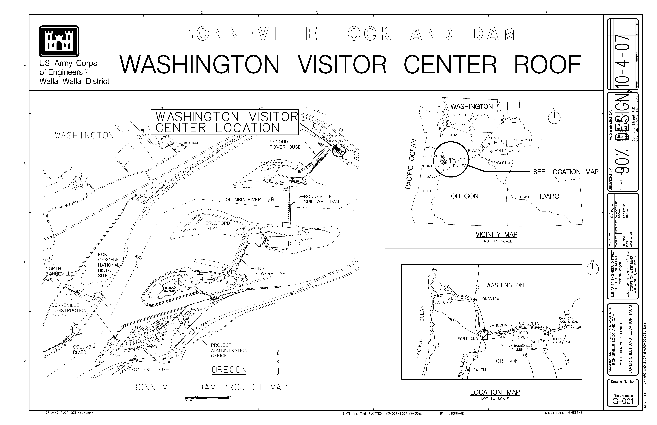
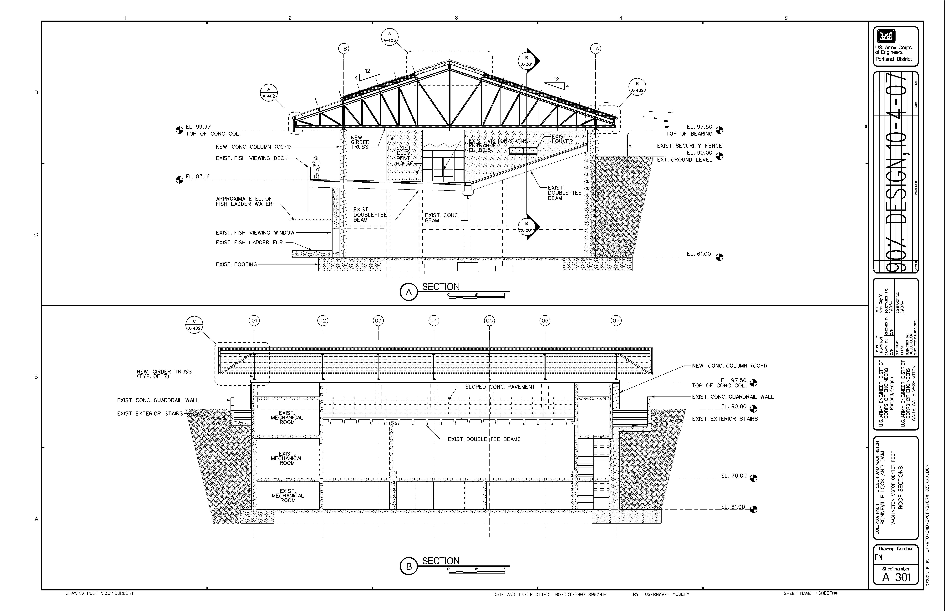
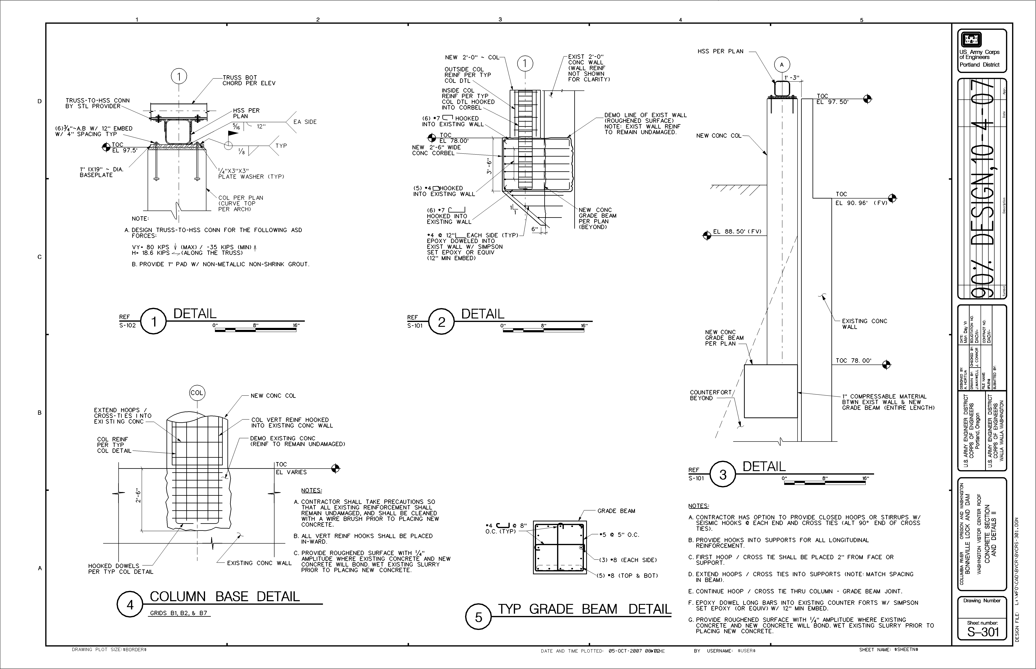
LOWER GRANITE – INSPECTION OF ADULT FISH TRAP & FISH LADDER WATER SUPPLY PIPE
Trip Report -- 13 August 2009

The water supply for the adult fish trap and Diffuser 14 in the fish ladder at Lower Granite is gravity flow from the forebay. The intake centerline is at El. 718 feet. From the intake, a 48-inch pipe passes through a 48-inch round gate valve into a wet well beneath the intake deck. From the wet well, a 36-inch pipe runs longitudinally through the dam for some distance before exiting the downstream face of the dam, where it is routed underneath the fish ladder to Diffuser 14. About 30 – 40 feet upstream of Diffuser 14, the two water supply pipes (18-inch and 8-inch diameter) for the adult fish trap tee off the 36-inch main supply pipe.
Previous reports have speculated that there may be some unknown restriction in this main supply pipe or in the upper end of the 18-inch supply pipe that is causing unforeseen head losses, and thus reduced water supply capacity, as seen in operation of the adult fish trap and fish ladder. The purpose of this inspection was to visually inspect the 48-inch and 36-inch pipes using a Remotely Operated Vehicle (ROV) to see whether there were any obstructions.
The adult fish trap was already shut down due to high water temperatures. Shutting off the auxiliary water supply to Diffuser 14 forces the fish ladder to operate out of criteria due to reduced head over the weirs. The inspection was done at night to minimize the disturbance to adult fish attempting to migrate up the fish ladder. In addition, the Auxiliary Pump #1 was turned on, which discharges water (about 25 cfs) from above directly into the fish ladder just downstream of the fish ladder exit.

Observations and Recommendations:
There were no observable obstructions in either the 36-inch or 48-inch pipes.

The 36-inch pipe is very rough – looks like rust or corrosion. It was speculated that the pipe was lined with concrete. However, construction drawings indicate that it is a 36-inch Schedule 10 black steel pipe. There is no indication on the drawings that it is lined with concrete. Upon review of the video, the pipe looks more like rough steel than concrete lining.

The trash rack was relatively clean. There were no obstructions in the 48-inch pipe or the intake.

The Diffuser 14 water surface elevation sensor readout in the valve room above the wet well read 727.8 feet during the inspection, which is about 0.2 feet below the target elevation during normal operation.

During the next winter maintenance period when the system is unwatered, the inside diameter of the 36-inch pipe should be measured and it should be confirmed whether the pipe is lined, and if so, with what material.

Either a smaller inside diameter or rougher pipe condition could affect the predicted hydraulic grade line and discharge capacity of the system. The hydraulic analysis should be reviewed to determine the extent of the impact due to differences in these variables.

As recommended in past reports, the 18-inch butterfly valve should be removed and inspected and/or replaced. Since there were no significant obstructions in the 36-inch pipe or inlet pipe, this in the next most likely location for higher than expected head loss.

If none of these actions yields satisfactory solutions or explanations for the depressed hydraulic grade line and reduced discharge capacity, more extensive testing using flow meters and pressure gages at various locations may be necessary to further isolate where the problem(s) is occurring.

Sean C. Milligan
Chief, Hydraulics & Water Quality Section
COE Reduced Entrance Velocity Operations at McNary Oregon Shore Fish Ladder FY09.
4 September 2009
The Walla Walla District Corps of Engineers is testing a reduced nighttime entrance velocity operation the McNary Dam Oregon Shore Fish Ladder during the Adult Pacific Lamprey run this summer and fall. This operation is anticipated to aid Pacific Lamprey passage at McNary Dam. This letter report contains t-test comparisons of adult salmon and lamprey passage obtained daytime fish counts. Adult fish window counts are compared to the treatment (reduced entrance velocity) and control (standard entrance velocities) to estimate the effects of the entrance condition on the fish entering and passing this ladder. Also included are pressure sensor data for relative head differentials at the ladder entrance weirs being tested.
Results:
Table 1. T-test comparison of dam counts with one day lag of control and treatment
conditions at McNary Dam July 1 through August14, 2009.
Species | Condition | Mean | Standard  deviation | t | P-value
Chinook salmon | Control | 398.5 | 354.4 | -0.863 | 0.393
 | Treatment | 497.5 | 404.2
Steelhead | Control | 661.8 | 397.8 | 0.032 | 0.974
 | Treatment | 658.6 | 280.9
Sockeye salmon | Control | 1201.3 | 2178.9 | 0.019 | 0.985
 | Treatment | 1189.1 | 2125.6
Lamprey | Control | 9.7 | 5.9 | 0.147 | 0.884
 | Treatment | 9.4 | 6.4
Shad | Control | 3486.4 | 5306.3 | 0.590 | 0.558
 | Treatment | 2697.4 | 3342.3

Figure 1. Dam counts of Chinook salmon and steelhead during control and treatment
conditions at McNary Dam McNary Dam July 1 through August14, 2009. Note solid lines are medians and pluses are means.
Figure 2. Dam counts of sockeye salmon during control and treatment
conditions at McNary Dam McNary Dam July 1 through August14, 2009. Note solid lines are medians and pluses are means.
Figure 3. Dam counts of lamprey during control and treatment conditions at McNary Dam McNary Dam July 1 through August14, 2009. Note solid lines are medians and pluses are means.
Figure 4. Dam counts of shad during control and treatment conditions at McNary Dam McNary Dam July 1 through August14, 2009. Note solid lines are medians and pluses are means.

September 21, 2009 NWR5/FCRPS

FILE MEMORANDUM

FROM: Gary Fredricks

SUBJECT: The Dalles Dam Ice and Trash Sluiceway Operation

The Dalles Dam is unique in the FCRPS dams that have fish anadromous passage in that it is the only dam without a specific bypass system designed for downstream migrants. During the fall and winter months (September through March) when there is no fish passage spill, the ice and trash sluiceway is the only non-turbine passage route at this dam. Operation of this sluiceway during the fall and winter months for fish passage purposes has been debated in the O&M committees for many years.

Historically, the discussions regarding operational dates have centered around the need for use of the sluiceway in November. Of particular concern has been the use of the sluiceway by adult salmon that, for various reasons, pass downstream through the project. A secondary concern has been for late migrating subyearling fall Chinook salmon. More recently, there have been increasing concerns for early spring migrating kelt steelhead. Because of the concern for kelt passage, the Region initiated sluiceway studies in 2009, to evaluate fish passage during the late fall and early spring periods. The current (2009) Corps Fish Passage Plan (FPP) indicates that this sluiceway will be operated with six open gates (approximately 5 kcfs) from April 1 through the end of November.

Previous Studies:

The previous The Dalles Dam sluiceway studies focused on juvenile passage during the peak migration months (April – August) with little effort on what was considered to be the off-season passage period. These studies indicated in general, that about 40-55% of the juvenile migrants that pass the dam pass through the sluiceway when no spill was occurring (Ferguson et al. 2005). The percent of project passage that passes the sluiceway is negatively related to the percentage of spill.

Until recently, there had not been any specific studies that assessed adult passage through this sluiceway. There have, however, been several years of general adult radio tag passage studies in the lower Columbia River that offer some insight into the potential usefulness of the sluiceway to adults. Keefer et al. (2008) summarized six years (between 1996 - 2003) of overwintering behavior and distribution of radio tagged summer steelhead in the hydrosystem. Steelhead originating from the Snake River system made up the majority of the overwintering population. They estimated that 12.4% of the fish that successfully reached spawning areas overwintered, at least partially, in the hydrosystem. These overwintering fish tended to actively move up and downstream during the overwintering months with the bulk of the upstream movement resuming in March. The downstream movement resulted in a fallback percentage of 20.5% of the overwintering population. Most importantly to the sluiceway operation issue, the largest number of fallback events occurred at The Dalles Dam (28%) with McNary and John Day not far behind with 20% at each dam. An examination of the ultimate fate of the overwintering steelhead population that did not return to the spawning areas indicated that a minimum of 14.5% had unknown fates (presumably died from either natural or human-related causes) within the section of the river covered by the hydrosystem.

Other studies have looked at survival of fallback salmonids. In examining fallback at Bonneville Dam, Boggs et al. (2004) found that in a year with normal spill (2000), 25% of the 55 radio tagged steelhead that fell back at the dam were unaccounted for after the fallback event. In a year with little spill (2001), about 45% of the 33 fallback tagged steelhead were not relocated after the event. The authors went on to say that for all years and species, escapement was higher for fish that did not fall back. While this study was not specific to The Dalles Dam, I believe it does illustrate that fallback at dams is dangerous for adult migrants and that additional non-turbine passage routes are likely to improve survival.

Recent Studies:

In the winter of 2008, the Corps contracted through the Pacific Northwest National Laboratory (PNNL) to investigate adult salmonid passage through the sluiceway. The investigation (Khan et al. 2009) used hydroacoustic (transducers and DIDSON) to enumerate adult passage through the sluiceway during two study periods, November 1 through December 15 and March 1 through April 9, 2009. The results indicate that about 1,750-1,800 adults passed the project during each period. Horizontal, vertical and daily passage distribution was similar for each study period. Most adults (64-85%) passed through the unit 1 sluice gates (1-1, 1-2, 1-3), with the second highest passage rate through unit 18 gates (18-1, 18-2) and the lowest rate through the gate at unit 15 (15-2). The lowest individual gate passage was through gates 1-1 and 15-2. Diel passage was well distributed across the 24 hour day and 95% of the passing adults passed through the sluiceway with the remaining five percent passing through the turbine units. Daily passage in the fall was fairly constant across the study period although it tended to fall off somewhat during the last week (after the first week of December). Late winter/early spring passage was more variable with some high passage days in early and late March, although passage was consistently higher after about March 15.

The DIDSON camera work also allowed identification of small targets and the researchers were able to determine that large schools of juvenile salmon (of unknown origin) were passing the sluiceway from late November to mid-December (as well as large numbers of juvenile shad).

Recommendation:

The radio tracking studies indicate that adult steelhead fallback has been occurring regularly at The Dalles Dam for many years and that the consequence of fallback, particularly without non-turbine routes, can be quite negative. A longer sluiceway operating season seems justified given the number of adults that were seen passing this sluiceway during the PNNL study and given the potential survival benefits of sluiceway passage. Operation of the sluiceway in this manner would also likely benefit the juvenile salmonids that are observed entering the sluiceway during the fall. Knowing the increase in sluiceway operation will be a contested issue in the region, a second year of data collection will likely be necessary before any long-term operational changes can be made. The value of a second test would be to see if the numbers of fish and the passage distribution is similar across years. Therefore, the second year of study should be conducted under sluiceway operating conditions that are similar to those used during 2008-9 test period. This would rule out any treatment tests with a blocked study design. We could also consider the effects of closing one or two of the least used sluice gates, particularly if this would make adoption of the extended season more likely to occur. The November portion of the gate closure would violate the operational requirements in the Corps’ FPP and should therefore be considered a one-time exemption for the 2009-10 test. The potential detriment to juvenile passage must be considered before any long–term sluiceway gate opening changes are made in the FPP.

Literature cited:
Boggs, C. T, M. L. Keefer, C. A. Peery and, M. L. Moser. 2004. Adult Chinook salmon and steelhead fallback at Bonneville Dam, 2000-2001. Technical Report 2004-4 to the U.S. Army Corps of Engineers, Portland and Walla Walla Districts. 49 p.

Ferguson, J. W, G. Matthews, L. McComas, R. Absolon, D. Brege, M. Gessel, L. Gilbreath. 2005. Passage of adult and juvenile salmonids through federal Columbia River Power System dams. NOAA Technical Memorandum NMFS-NWFSC-64.

Keefer, M. L. C. T. Boggs, C. A. Peery and, C. C. Caudill. 2008. Overwintering distribution, behavior, and survival of adult summer steelhead: variability among Columbia River populations. N. A. Journal Fish. Man. 28:81-96.

Khan, F, M. Weiland, and G. Johnson. Evaluation of adult salmonid downstream passage through the sluiceway and turbines at The Dalles Dam during late fall, winter and early spring. Powerpoint presentation to the Corps Portland District Fish Facility Design Review Work Group.
CENWP-OD-B

MEMORANDUM FOR THE RECORD

SUBJECT: BONNEVILLE DAM WINTER FISHWAY MAINTENANCE 2008/2009.

- This is a working document detailing Bonneville Dam winter fishway maintenance, 2009/2010. Reviewers can expect changes as we approach the winter maintenance season.

- ADULT FISHWAYS
  - Fish Unit Outages
    - Fish Unit 1: 01 Dec 09 – 15 Jan 10, annual overhaul.
    - Fish Unit 2: 15 Jan 10 – 28 Feb 10, annual overhaul.

  - UMT (1 Dec 09 – 03 Dec 09)
    - Install north UMT bulkhead on 01 Dec 09 for Smith-Root work.
    - Install south UMT bulkhead on 01 Dec 09 for Smith-Root work.
    - Pump UMT dry and salvage fish 01 Dec 09. (Riggers/Fish)
    - Install new electro-barrier (Smith-Root)
    - Remove bulkheads on 04 Dec 09.

  - Bradford Island Ladder (A&B-Branches 05 Dec 09 – 28 Feb 10)
    - Go to orifice flow on 05 Dec 09
    - Dewater to tailwater on 07 Dec 09
    - Dewater diffuser pools on 08 Dec 09.
    - Inspect Bradford Island exit trashrack.
    - Clean staff gauges.
    - Inspect, repair, and clean picket leads.
    - Provide additional strapping for PIT tag equipment, as necessary. (Electricians)
    - Maintain the LPS. Fix leaky joint (Painters)
    - Remove crowder. Clean, paint and replace white board. (Painters)
    - Clean count window. (Painters)
    - Remove weeds near PIT tag room and transceiver enclosures. (Garage)
    - Remove blackberry bushes in and around fishways. (Garage)
    - Remove dead trees at BI exit (Riggers).
    - Extend FV3-7 inner trashrack. (Riggers) Rerecich to submit TR early.
    - Install SLEDS or acoustic deterrents by 01 Feb 09
    - Dredge BI fish exit. 2009/2010 (contractor)

A-Branch and PH1 collection channel specific items
    - Install south end bulkhead for dewatering.
    - Calibrate CC, TW, and entrance gate transducers.
    - HSS inspect FV1-1. (Tech staff and NWP engineers)
    - Replace wooden bulkhead at south end of PCC.
    - Design repair FG2-22A and FG2-19.
    - Install new metal staff gauges at north and south end of PCC. (Riggers)
    - Install new mechanical velocity meter at north end.
    - Dewater FV3-7 conduit. Inspect and repair joints.
    - Inspect/repair hole at FG3-12. (Riggers, garage)
    - Inspect weirs adjacent to FG3-6 (Riggers)
    - Clean staff gauge at FG3-9 area. (Riggers)

B-Branch specific items
    - Calibrate CC, TW, and entrance gate transducers.
    - Install new metal staff gauges. (Riggers)
    - Inspect entrance pool 11 Jan 10. (ROV inspection)

  - Cascades Island Ladder and UMT (Not going OOS)
    - Remove large vegetation around fishways (blackberry bushes). (Garage)
    - Inspect entrance pool 11 Jan 10. (ROV inspection)
    - Install SLEDS or acoustic deterrents by 01 Feb 10

  - Washington Shore Ladder (Not going OOS)
    - Install stab plates when one fish unit goes OOS.
    - Install SLEDS or acoustic deterrents by 01 Feb 10
    - Inspect PH2 PCC 11 Jan 10. (ROV inspection)

  - Adult Fish Facility (07 Nov 09 – 1 Apr 10
    - Go to orifice flow on 07 Nov 09
    - Chase fish to the ladder on 09 Nov 09
    - Dewater exit section on 09 Nov 09
    - Routine maintenance.
    - PM bridge crane.
    - Repair broken gate cranks and pulleys.
    - Inspect and repair weir doors.
    - Clean fish viewing window. (Painters)
    - Pressure wash the lab and handrails. (Painters)
    - Replace silicone around the anesthetic tank bottom. (Painters)
    - Secure bottom of temperature probe stillwell. (Electricians)
    - Replace broken timbers in exit section with bulkhead. (Riggers)
    - Valve 15 fish chute for morts. (Fish/Tech staff)
    - Repair/Replace netting over flumes. (Project Fisheries)
    - Inspect floor drain. (plumbing contractor)
    - Roof repair. (contractor) September.

- JUVENILE FISHWAYS
  - B2 Corner Collector (31 Aug 09 – 01 Mar 10)
    - Remove mice from the pull box between the PIT tag building and the Electrical building and possibly set traps for future occupants.
    - Enter the channel to inspect seals around antennae and skid plates.
    - Install bulkhead hoist. (contractor)

  - DSM 1/ ITS (01 Nov 09 – 28 Feb 10)
    - Install bulkheads and dewater starting 01 Nov 09.
    - Paint elevation marks on chain gates 1A, 1B, 1C, 3C, 6C, 10B (Painters).

  - Juvenile Monitoring Facility (31 October 09 – 22 February 10)
    - Blow out hydro cannon lines on 01 Sep 09 (Operators)
    - Drain and inspect sample flume on 31 Oct 09. (Project Fisheries)
    - Inspect and PM equipment- air pressure gauges and oil/water traps.
    - Inspect flume joints. Re-caulk as needed.
    - Inspect and winterize 2 and 3 way rotating gates.
    - Replace charcoal filters.
    - Inspect/Repair lifting cables for the fish lifts. (Riggers)
    - Replace lower gasket for the adult flume flushing water.
    - Replace hopper flushing water gasket.
    - New seals on upper switchgate.
    - Seal off drain pipe to western wildlife pond.

  - DSM 2 (15 Dec 09 – 19 Feb 10)
    - Turn off orifice lights on 13 Dec 09
    - Pull STSs 15-16 Dec 09
    - Dewater DSM on 17 Dec 09
    - Inspect two mile pipe on 21 Dec 09
    - Replace VBS seals. (Riggers)
    - PM equipment.
    - Inspect/Repair screen cleaners. Needs to be operable.
    - Install STSs starting 22 Feb 10
    - Water up when STSs are installed (not later than 28 Feb 10)

- SPILLWAY
  - Test all gates.
  - Repair gate 15 hoist.

KEY TO COLORS-
Black- normal/routine dewatering work
Orange- work to be done by contractors or researchers.
Blue- work to be done by Fisheries
Pink- highlights special requests or non-routine work items.
THE DALLES DAM FISHWAY DEWATER SCHEDULE
WINTER ‘09/’10

East Fish Ladder -Dewater Dec 2, ’09 – Jan 27, ‘10

Repaint 1’ mark on weir 158-9 (TJF)
- Install new rubber on 158-9 side plates (TDS)
- PM weirs 154-9 and CS equip (TDS,TDM,TDE)
- Eng inspect 154-9 weirs
- Repair FB staff gauge #s (TDS)
- Clean staff gages and pickets (TJF)
- Lamprey mods; d/s count station, 180 bend, last ladder weir (Eng contract)
- Repair Expansion joints (Eng)
- Re-floor/repaint count stations and new roof east station (TDM, Eng)
- Full range operation tests all weirs (TDS, TJF)
- Remove/inspect fish unit trashrack (TDS)

East, West and South Ent, Junct Pool, Collection and Trans Chan-Dewater Dec 7, ’09
- Install replacement diffuser grating where needed– Eng inspect. (TDS)
- PM entrance weirs (TDM, TDE)
- Full range operation test (TDS, TJF)
- Lamprey mod; south entrance pool (Eng contract)

North Fish Ladder - Dewater Feb 8 - 26, ‘10
- PM CS equipment and PUD radial (PUD provide labor)
- Remove brush from fish ladder walls (TJF)
- Repair loose guide and install rubber gaps of debris guard (TDS)
- Replace count station diffuser grating – (Eng)
- Full range operation test (TDS, TJF)
- Re-floor/repaint count station (TDM)
- Repair loose rail on exit debris guard and install rubber seal.(TDS)
- Fabricate debris guard PUD intake (Eng and TDS) determine need

North Entrance - Dewater Feb 9. ‘10
- PM weir N1 (TDM, TDS)
- Full range operation test (TDS, TJF)
- Lamprey ramp; north entrance pool (contract)

ROV inspect PUD intake trashrack -ROV Feb 18, ’09
Project ROV
JOHN DAY DAM FISHWAYS’ DEWATER SCHEDULE
WINTER ‘09/’10

North Fish Ladder -Dewater Nov 16, ’09 – Mar 15, ‘10

JDNFL construction support
- PM count station and exit hydraulic weirs (JDM,JDE)
- Remove count station ¾” grating for south installation (?)
- Shim picket leads up 1” (JDS) – done?
- Check welds on debris guard

North Entrance -Dewater Dependent on dist. visit
- PM entrance weirs (JDM, JDE)
- JDNFL district site visit support
- Measure weir chain (TJF)

Juvenile Bypass System -Dewater Dec 15, ’09
- Repair flume spalling
- Repair SMF separator tub rust
- Inspect conduit (Engineering)
- PM all SMF equipment and tainter gate (JDM, JDE)

South Turbine Bulkhead Install -ROV Jan 11
- Inspect seal and south turbine intake for debris
- Inspect south pump stilling basin trashrack
- Inside penstock inspect – done last yr?

South Fish Ladder - Dewater Jan 12 -21, ‘10
- Repair broke welds on debris guard boom
- PM count station equipment and exit sills (JDM,JDE)
- Expansion joint repair exit (JDS)

South Entrance, Collection channel - Dewater Jan 25 – 28, ‘10
- PM SE1, NE1/2 entrance weirs (JDM, JDE)
- SE1 wall diffuser – seal off (JDM, Engineering)
- PM NE3 spare gearbox (JDM)
- Inspect diffuser valves (JDM, Engineering)
- Taillog install for south turbine rehab #2
- Measure weir chain (TJF)

South fish turbine trashrack install -ROV Jan 29, ‘10
- Inspect sill
- Inspect forebay north and south diffuser intakes
CENWP-OD-SRF 8 September 8, 2009

MEMORANDUM FOR FILES:

SUBJECT: John Day north ladder baseline study for fish jumping and count station fallback

1. In anticipation of major modifications to the John Day north ladder, conduct a study to collect baseline data to form a “before” database to compare with the results “after” completion of the modifications.

2. The primary area of interest is fish jumping in the upper portion of the overflow section and the flow control section of the ladder. This study would be conducted in a manner similar to the 1993 – 2001 “Jump Studies” as well as the 2003 South Ladder Evaluation. Use on-site observers to make observations four hours per day Monday – Friday (2 hours overflow and 2 hours flow control) during the “jumping” season September – October. Tally the jumps by location in the ladder and identify to species whenever possible.

3. Collect the “before” data in the fall of 2009, and collect the “after” data in the fall after the ladder modifications are completed. Use the same methods in both seasons to enable a statistical comparison. Run a Student’s t-Test to compare the number of jumps per sampling period “before” and “after” construction for both the overflow and flow control sections.

3. The secondary area of interest would be to tabulate existing data about fallback through the count station in a format that could be compared with post-construction fallback. Determine the rate of fallback using up and down counts through the north ladder window for 2009 and the year following completion of the modifications. Run a Student’s t-Test to compare fall back rates for the two years.

4. During both years, deploy underwater cameras in the fishway upstream of the counting slot to document passage before and after completion of the modifications. Camera deployment would not be fixed in one location, but include shots of the count slot exit and the south orifice at weir 249. The camera would be briefly (up to an hour at a time) deployed at these locations throughout the study to document fish behavior in the transition pool above the count station.

MIKE R. JONAS
Biological Science Technician

August 2009
Sunday | Monday | Tuesday | Wednesday | Thursday | Friday | Saturday
 |  |  |  |  |  | 1
2 | 3  ERDC- MCN | 4  FPAC  TDA ROV  ERDC- MCN | 5  JDA ROV  BON ROV  ERDC- MCN  BON trashrack mtg | 6  ERDC- MCN | 7  ERDC- MCN | 8
9 | 10  Corps golf tournament | 11  FPAC | 12  TMT  SRWG- preliminary review | 13  SRWG- preliminary review | 14  SRWG- preliminary review | 15
16 | 17  AFF mtg @ BON | 18  FPAC | 19 | 20  SCT  FPOM- NOAA | 21 | 22
23 | 24  ERDC- JDA | 25  FPAC  ERDC- JDA | 26  TMT  ERDC- JDA | 27  ERDC- JDA | 28  ERDC- JDA | 29
30 | 31

September 2009
Sunday | Monday | Tuesday | Wednesday | Thursday | Friday | Saturday
 |  | 1  FPAC | 2 | 3  BON PH1 STSs installed by today  NWP – FFDRWG | 4 | 5
6 | 7 | 8  FPAC  TDA spill wall work scheduled to begin | 9  TMT | 10  FPOM Meeting  TDA spillwall call | 11 | 12
13  Happy Birthday | 14 | 15  FPAC | 16 | 17  Happy Birthday | 18 | 19
20 | 21  JDA avian array mtg | 22  FPAC | 23  TMT  JDA deflector mtg  JDA LRAD demo | 24  TDA spillwall call | 25 | 26
27  Happy Birthday | 28 | 29  FPAC | 30

October 2009
Sunday | Monday | Tuesday | Wednesday | Thursday | Friday | Saturday
 |  |  |  | 1 | 2 | 3
4 | 5  MCN COP alternatives- Portland | 6  MCN COP alternatives (in PDX) | 7  NWW- Eonfusion demo | 8 FPOM- NOAA  TDA spillwall call | 9  Happy Birthday | 10
11 | 12 | 13 | 14 | 15 | 16  Happy Birthday | 17
18 | 19  Happy Birthday | 20 | 21  AFEP final proposals sent  FFDRWG- NWP  NWW (in PDX)- forebay/tailrace influence for each project | 22  TDA spillwall call | 23 | 24
25 | 26 | 27 | 28  FFDRWG-NWW | 29  FFDRWG- NWW | 30 | 31  Normal Adult Fish Counting Ends Most Dams  BON JMF to bypass

CENWP-OD 09 September 2009

MEMORANDUM FOR THE RECORD

Subject: DRAFT Minutes for the 17 August 2009 BON AFF meeting.

The meeting was held at Bonneville Lock and Dam. In attendance:
Last | First | Agency | Office | Email
Baus | Doug | USACE | 503-808-3995 | Douglas.M.Baus@usace.army.mil
Clugston | David | USACE | 503-808-4751 | David.a.clugston@usace.army.mil
Fredricks | Gary | NOAA | 503-231-6855 | Gary.fredricks@noaa.gov
Klatte | Bern | USACE | 503-808-4318 | Bernard.a.klatte@usace.army.mil
Mackey | Tammy | USACE | 503-808-4305 | Tammy.m.mackey@usace.army.mil
Rerecich | Jon | USACE | 541-374-7984 | Jonathan.g.rerecich@usace.army.mil
Schwartz | Dennis | USACE | 541-374-4567 | Dennis.E.schwartz@usace.army.mil
Whiteaker | John | CRITFC |  | Whij@critfc.org
 | Winfred | CRITFC
 |  | CRITFC

These are not as detailed notes as in the past. The purpose of the meeting was to discuss changes to the AFF and to the way information is gathered.

Small issues that could be dealt with in the near future-
- Do we still need the lamprey flume? It was suggested the flume may have outlived it’s usefulness at the AFF. Clugston will look into the need or lack of and possibility of removing it.
- Might be able to install more extensive holding tanks in the area that would be opened up by the removal of the lamprey flume. The benefit would be that daily ladder passage diversion time into the facility could be reduced. Water to water transfer of fish to the anesthetic tank would be a problem.
- The anesthetic tank has a small drain on the east side. Could that be replaced so the tank drains faster? USACE recommended attaching a hose to the larger west drain and running it to the wall drain. This would be easier and cheaper than trying to get the tank re-plumbed.
- The wall drain drains slowly. USACE reported that mechanics and plumbers have looked at that drain. No one seems to be able to determine the problem but they will look at it again this winter and call in a professional to snake it.
- The brail pool has a gap between the exit gate and the floor. The gap allows steelhead to get under the brail. The team looked at the gap. It may require major modifications to the brail pool.
- Move the brail pool exit to the south of the current location to give fish more time to orient before encountering the drain.
- Rubber flat at end of ramp to anesthesia tank needs modification for all sizes/species of fish that enter. The team looked at this. USACE committed to looking at different weights of neoprene, but the researchers may need to prepare to manually lift the flap when sampling smaller fish.
- Reduced flow to the AFF. USACE will request the Riggers clean the FERL intake screen (located just north of the fish units, in the forebay).

Larger and long term issues-
- CRITFC requested a facility at the count windows. Due to the space limitations there, it would be very difficult to get a handling facility in the fish viewing window area of the visitor center.
- NOAA Fisheries suggested razing the building and starting over. They would also like to see reduced reliance on the AFF.
- Need to assemble a task force to look at the future need; the need for sorting, handling, properly sizing tanks and providing enough water.
- Need to meet with TAC-Harvest to discuss future use.
- There may be a group working on the Basin-wide sampling/tagging. It was suggested the AFF team find this group and see if efforts could be coordinated, especially when it comes to tagging fish needed by CRITFC for harvest management. Also find the PIT tag group working on tag analyses; find out status

FISH PASSAGE O&M COORDINATION TEAM

Adult and Juvenile Fish Facilities Status Report

U.S. Army Corps of Engineers, Walla Walla District

September 10, 2009

Construction
McNary:
- Unit 1 taken out of service August 10 for annual maintenance; unit 2 taken out of service July 10 for 9-year overhaul.
- Turbine unit 5 taken out of service August 17 for annual maintenance. Return to service depends on when mobile crane service becomes available.
- Turbine unit 6 taken out of service August 19 for removal of water from the hub. The intake deck crane failed while removing a headgate from turbine unit 6. The turbine unit’s return to service will depend when safe removal of crane from slot 6B is possible and when mobile crane service becomes available.
- Turbine units 7 & 8 remain out of service for transformer T4 replacement,
Ice Harbor: Units 1 & 2 returned to service for annual maintenance and installation of lightning arrestors on bus bars; unit 3 taken out of service August 25 for annual maintenance; unit 4 remains out of service due to ripped VBS screen.
Lower Monumental: Turbine unit 6 returned to service from annual maintenance August 25.
Little Goose: Unit 1 returned to service from annual maintenance on September 3; units 5 & 6 originally removed from service August 17 in support of Doble tests remained out of service due to a faulty electrical bushing until September 2
Lower Granite: Transformer line 2 outage limited turbine unit 2 generation until August 25 when the line returned to service; unit 6 taken out of service August 3 for annual maintenance.

Operations and Maintenance - Juvenile Fish Facilities: Collection for fish transport continues at Lower Granite, Little Goose and Lower Monumental and McNary dams. All locations began fish truck operations on August 16.
McNary: North powerhouse loading remains in effect for temperature abatement in juvenile fishway.
Ice Harbor:
- Screen cleaner power supply failed August 4. Repair parts have been ordered. Powerhouse operators and fish facility personnel are the monitoring collection channel and inclined screen.
- A six inch by 2 foot rip found in VBS in slot 4A. Slot dipped for fish and bulkheads set in place for repairs on August 20. No fish recovered. Repairs completed August 24.
Lower Monumental: STSs switched from continuous to cycle mode on July 30 as average fork length of juvenile sockeye and Chinook are now greater than 120 mm.
Little Goose:
- The primary dewaterer weir motor failed July 20 and is currently undergoing repairs. Water levels are being maintained by the opening and closure of orifices.
- Turbine unit 1 trash racks raked August 17 and 18. Approximately 1 – 2 cubic yards of material removed. A large log obstructs spans across all 3 trash racks. A plan of action is being formulated for log removal.
Lower Granite: VBS inspections conducted August 21-23 revealed problems in slots 3A, 3B and 4B. A bar was missing 3 bolts on the top VBS in slot 3A. A large amount of debris was encountered 22 feet down on a VBS in slot 3B (possible tear). Debris and a gap in the screen material were noted 29 feet down on the VBS in slot 4B.

Operations and Maintenance - Adult Fish Facilities
McNary:
- Oregon Ladder: North AWS taken out of service May 28 following failure. South AWS continues to provide sufficient water. South AWS trash rack raked August18 with the help of divers. Divers discovered at least one broken basket and separated carrier chain at the north AWS. Since repairs will require an extended outage and a large floating crane, this work has been deferred until the next winter maintenance period. In the meantime, the south AWS is providing sufficient water to meet fish passage needs through the gravity-fed conduit.
- Fish Pumps: Pumps #1, #2 & #3 are in service. Potable water supply problems are causing interruptions in service as domestic water is used to cool pump bearings. Maintenance personnel are still working to isolate and resolve the supply problems.
Ice Harbor:
- North Shore Fish Pumps: Fish pumps #1 & #2 in service. Fish Pump #3 on standby.
- North Shore Channel: Sonar based channel elevation measuring equipment failed July 28. Older meta-tape measuring system placed into service. Repair parts ordered.
Lower Monumental: Fish Pumps 1 & 2 in service. Fish Pump #3 remains out of service for diffuser assembly repairs and bearing housing replacement.
Little Goose:
- NPE3: The bulkhead sealing off this entrance is cracked and water is flowing into the spill basin. NSE-2 weir depth has been raised to 2.5 feet to maintain channel - tailwater differentials at the north shore. Otherwise, fishway performance does not appear to be adversely affected at this time and adult fish are successfully passing the count window. Repairs will likely take place during the winter maintenance season.
- Adult collection channel: A two foot section of the fallout fence has separated from the support frame. Adult fish appear to be passing though this area safely.
Lower Granite: Fish pumps 1 and 3 in operation. Fish pump 2 repairs completed July 10 and placed in standby status until planned tests can be completed.

Other: Spill Ended at all locations on August 31.
McNary: Juvenile lamprey research ended with the close of barge operations. Adults lamprey study still in progress.
Ice Harbor:
- RSW in operation.
- Cooling water strainers in turbine units 1, 2 and 4 were inspected August 17. One juvenile lamprey mortality was recovered from the turbine unit 1 strainers and an unidentifiable mortality was found in the turbine unit 4 strainers.
- Turbine unit 3 cooling water strainer checked August 25 – no fish found.
Lower Monumental: Cooling water strainers inspected August 19, no fish found.
Little Goose: Cooling water strainers were inspected in turbine units 1,2,4,5 and 6 on August 10. No fish were found.
Lower Granite:
- Adult trap operation suspended July 19 due to high water temperatures and problems with the slide gate air valve control to the anesthetic tank. Trap operations resumed August 18.
- Cooling water strainers inspected in turbine unit 4 on July 14. One live and 3 dead juvenile lamprey were recovered.

